**Assignment Subjective Questions**

1. **Which are the top three variables in your model which contribute most towards the probability of a lead getting converted?**

Ans. These are the three variables that contribute most towards the probability of a lead getting converted. These

are found on the basis of data visualization and correlation matrix.

1. Total Time Spent On Website

* Leads spending more time on the website are more likely to be converted.

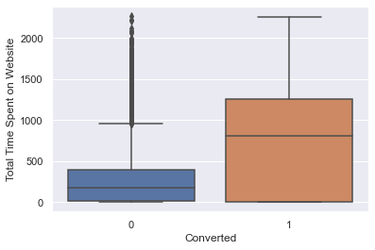

1. Lead Origin

* Landing Page Submission and API bring high number of leads as well as conversion(converted=1)

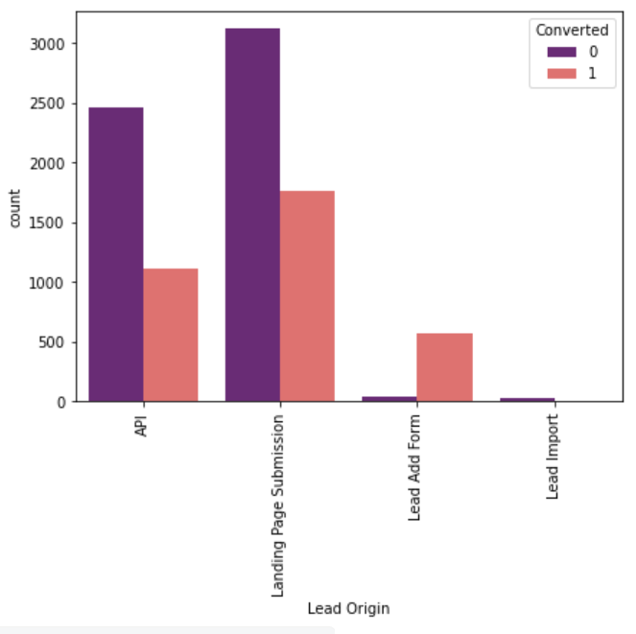

1. Last activity

* Last activity performed by the customer in which email opened bring high number of leads and converted lead. SMS sent has high converted lead.

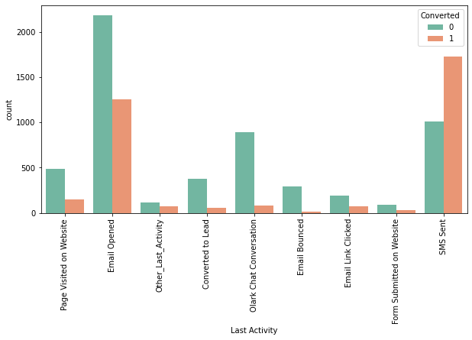

1. **What are the top 3 categorical/dummy variables in the model which should be focused the most on in order to increase the probability of lead conversion?**

Ans. The three categorical variables are on the basis of visualization are as follows-

1. Lead Source-Google and Direct traffic

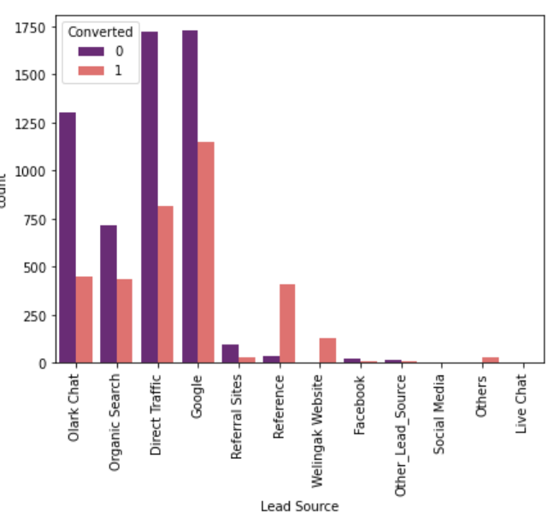

1. Last Activity

* SMS sent and Email opened



1. Specialization

* Different Management Specialization has high lead conversion.

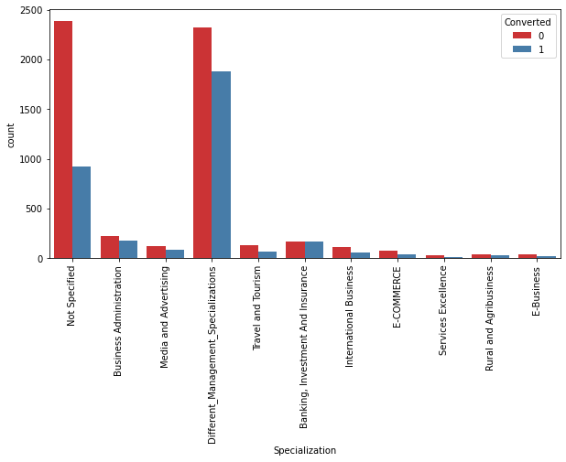

1. **X Education has a period of 2 months every year during which they hire some interns. The sales team, in particular, has around 10 interns allotted to them. So during this phase, they wish to make the lead conversion more aggressive. So they want almost all of the potential leads** **(i.e. the customers who have been predicted as 1 by the model) to be converted and hence, want to make phone calls to as much of such people as possible. Suggest a good strategy they should employ at this stage.**

Ans. The task to aggressively convert the leads using the interns ,hired during the period of 2 months, by sales team has

some of the ideas which can be useful-

* Social Networking and Publishing- Consumers today rely on their social networks to find advice, referrals, and reviews. Meet your customers by developing an active presence on the networks that make the most sense for your business. Social media can also indirectly impact your search engine rankings.
* Pay Per Click Campaigns- Pay-Per-Click (PPC) campaigns allow you to pay websites for sharing your advertisement. You only pay when someone clicks on your ad or by the number of impressions your ad receives .You should use PPC campaigns to drive traffic to landing pages where you’ll convert prospects by capturing their email addresses.
* Traditional Public Relations- A prospect may be technically offline, but with mobile phones always at reach, the opportunity for an immediate action still exists. The SMS call to action in the television commercial below generated 52% of the total entries for the content, even though it ran in only 25% of the ads.
* Email- You can begin to educate prospects about your business and build trust using a simple email. Send an automated email to subscribers with answers to the ten most frequently asked questions about your service. If you’re not doing any email marketing yet, this is an effective way to get started

1. **Similarly, at times, the company reaches its target for a quarter before the deadline. During this time, the company wants the sales team to focus on some new work as well. So during this time, the company’s aim is to not make phone calls unless it’s extremely necessary, i.e. they want to minimize the rate of useless phone calls. Suggest a strategy they should employ at this stage.**

Ans. During this time they should focus on other channels like

* the SMS
* social media
* automated mails etc.

These channels will also bring good result.